KEYBOARD ACCELERATORS

Keyboard accelerators are key combinations that let users quickly run commands without using the mouse. They usually combine a modifier key (such as **Ctrl**, **Alt**, or **Shift**) with another key (like **A**, **B**, or **C**).

Purpose of Keyboard Accelerators

Keyboard accelerators are useful because they:

* **Increase efficiency**: Users can perform actions faster without switching between mouse and keyboard.
* **Reduce eye strain**: Less need to look back and forth between the screen and input devices.
* **Improve accessibility**: They help users who may have difficulty using a mouse by offering keyboard-based control.

Common Keyboard Accelerator Usage

Keyboard accelerators are widely used in various software applications, including:

* **Word Processors:**Copy (Ctrl+C), Paste (Ctrl+V), Undo (Ctrl+Z), Redo (Ctrl+Y)
* **Web Browsers:**   
  Open New Tab (Ctrl+T), Close Tab (Ctrl+W), Switch Tabs (Ctrl+Tab/Ctrl+Shift+Tab), Save Page (Ctrl+S)
* **Operating Systems:**Cut (Ctrl+X), Copy (Ctrl+C), Paste (Ctrl+V), Undo (Ctrl+Z), Redo (Ctrl+Y), Save (Ctrl+S), Print (Ctrl+P)

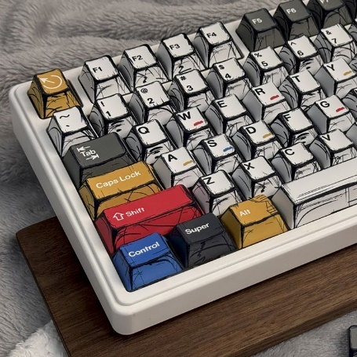

Implementing Keyboard Accelerators

Keyboard accelerators can be added to programs in several common ways:

* **Windows API**: Windows provides functions such as CreateAcceleratorTable and TranslateAccelerator to define and process keyboard shortcuts in native Windows applications.
* **Cross-platform toolkits**: Toolkits like **Qt** and **GTK+** include built-in support for keyboard accelerators, making it easier to use the same shortcuts across different operating systems.
* **Application frameworks**: Frameworks such as **.NET** and **Electron** offer higher-level tools to define and handle keyboard shortcuts without dealing directly with low-level system calls.

These options let developers choose the approach that best fits their platform and application needs.

Benefits of Keyboard Accelerators

**For users**

* Faster work and better efficiency
* Less eye strain (less switching between mouse and keyboard)
* Better accessibility for users who prefer or need keyboard input
* Higher overall productivity

**For developers**

* Cleaner menus with fewer items
* Simpler command access logic
* Better overall user experience

Encouraging Users to Use Keyboard Accelerators

Developers can help users adopt shortcuts by:

* **Showing shortcuts clearly** next to menu items or in a shortcut list
* **Providing documentation or help** that explains common shortcuts
* **Allowing customization** so users can change shortcuts to suit their needs

Guidelines for Assigning Keyboard Accelerators

When choosing keyboard shortcuts, keep these rules in mind:

* **Be consistent** with common programs so users don’t have to relearn shortcuts
* **Avoid system keys** like Tab, Enter, Esc, and Spacebar
* **Use modifier keys** (Ctrl, Alt, Shift) to avoid conflicts
* **Support old and new shortcuts** when users may expect both
* **Reserve F1 for Help**
* **Avoid F4, F5, and F6**, as they are commonly used by Windows and MDI applications

Following these guidelines helps create shortcuts that are easy to learn, safe to use, and consistent with Windows standards.

Examples of Recommended Keyboard Accelerators

Here's a table of common keyboard accelerators and their associated functions:

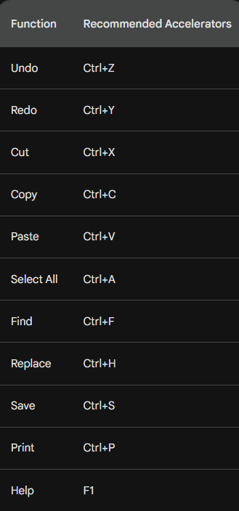

THE ACCELERATOR TABLE

An accelerator table is a data structure that defines keyboard shortcuts for menu items and other actions in a Windows application. Each entry in the table specifies an ID, a keystroke combination, and the corresponding menu item or action.

Defining Accelerators in Developer Studio

* You can define accelerator tables using the Accel Properties dialog box in Developer Studio. To create an accelerator table:
* Select the menu item or action for which you want to define a shortcut.
* Right-click and select "Properties" from the context menu.
* In the Properties dialog box, click the "Accel" button.
* In the Accel Properties dialog box, enter a keystroke combination in the "Keystroke" field. You can use virtual key codes, ASCII characters, or a combination of both in conjunction with the Shift, Ctrl, or Alt keys.
* Click "OK" to save the accelerator.
* Loading the Accelerator Table in Your Program.

To load an accelerator table into your program, you use the LoadAccelerators function. This function takes two parameters:

* hInstance: The handle to the program's instance.
* lpAcceleratorName: The name of the accelerator table resource. The resource name can be a string or a number.

Here's an example of how to load an accelerator table named MyAccelerators:



Once the accelerator table is loaded, you can use it to translate keystrokes into menu IDs or actions. The TranslateAccelerator function takes three parameters:

* hWindow: The handle to the window that receives the keystroke.
* hMsg: The handle to the message that contains the keystroke.
* wParam: The wParam value of the message.

The TranslateAccelerator function returns a menu ID if the keystroke matches an accelerator in the table. If the keystroke does not match an accelerator, it returns 0.

Here's an example of how to use the TranslateAccelerator function:



If menuID is not 0, it is the ID of the menu item that corresponds to the keystroke. You can then use this ID to perform the corresponding action.

Tips for Defining Accelerators

When defining accelerators, keep the following tips in mind:

* **Use consistent keystrokes** for similar actions. For example, you might use Ctrl+Z for undo and Ctrl+X for cut.
* **Avoid using keystrokes that are already used by Windows.** For example, you should not use Ctrl+C for copy, as this is already used by Windows.
* **Use descriptive keystrokes.** For example, you might use Ctrl+F for find and Ctrl+H for replace.

Loading the Accelerator Table

The LoadAccelerators function is used to load an accelerator table into memory and obtain a handle to it. The syntax of the LoadAccelerators function is as follows:

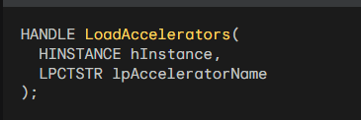

The hInstance parameter is the handle to the program's instance. The lpAcceleratorName parameter is the name of the accelerator table resource. The resource name can be a string or a number.

Here's an example of how to load an accelerator table named MyAccelerators:



Translating Keystrokes

The TranslateAccelerator function is used to translate a keystroke message into a menu ID or action. The syntax of the TranslateAccelerator function is as follows:

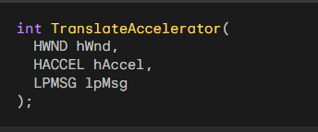

The hWnd parameter is the handle to the window that receives the keystroke. The hAccel parameter is the handle to the accelerator table. The lpMsg parameter is a pointer to the message structure that contains the keystroke.

The TranslateAccelerator function returns a menu ID if the keystroke matches an accelerator in the table. If the keystroke does not match an accelerator, it returns 0.

Here's an example of how to use the TranslateAccelerator function:

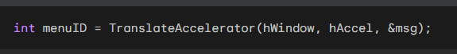

If menuID is not 0, it is the ID of the menu item that corresponds to the keystroke. You can then use this ID to perform the corresponding action.

Integrating Keyboard Accelerators into the Message Loop

To integrate keyboard accelerators into the message loop, you can modify the standard message loop as follows:

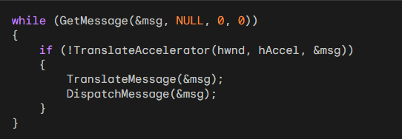

This code will first check whether the keystroke can be translated using the accelerator table.

If it can, the TranslateAccelerator function will send the corresponding message to the window procedure.

Otherwise, the code will continue with the normal message loop processing.

Understanding the hwnd Parameter

The hwnd parameter tells Windows **which window should receive the keyboard shortcut**.  
If you do not specify hwnd, the shortcut is sent to **whatever window currently has focus**.

Keyboard Accelerators and Modal Dialogs

Keyboard accelerators **do not work** when a modal dialog box or message box is active.  
This happens because dialog boxes and message boxes **do not use the normal message loop** of your program.

If you really need keyboard shortcuts to work inside a modal dialog or message box, you must use a different method.  
One option is to install a **keyboard hook** using SetWindowsHookEx, which allows your program to intercept key presses **before** they reach the dialog.

In practice, most programs **do not do this**, since keyboard shortcuts are usually disabled while modal dialogs are open.

Types of Accelerator Messages

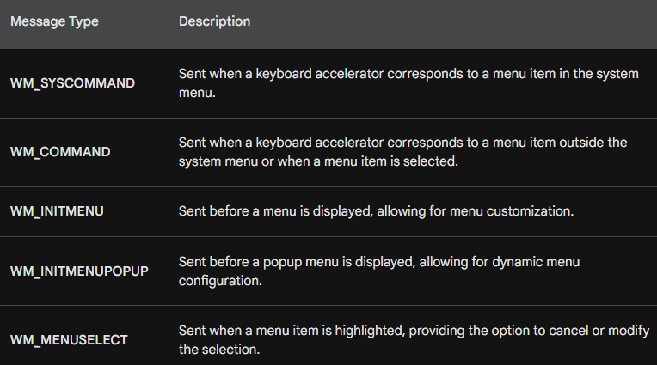

How TranslateAccelerator Works

TranslateAccelerator converts key presses into Windows messages.  
It sends **either WM_SYSCOMMAND or WM_COMMAND**, depending on what the shortcut is linked to.

System Menu Accelerators → WM_SYSCOMMAND

If a keyboard shortcut matches an item in the **system menu** (such as Restore, Move, or Close),  
Windows sends a **WM_SYSCOMMAND** message to the window procedure.

This means the command was triggered from the system menu using the keyboard.

Other Menu Accelerators → WM_COMMAND

If the shortcut matches a **normal menu item** (not part of the system menu),  
Windows sends a **WM_COMMAND** message instead.

WM_COMMAND Message Information

WM_COMMAND includes details about the command:

* LOWORD(wParam) → command or accelerator ID
* HIWORD(wParam) → notification code
* lParam → handle of the control (if applicable)

Extra Menu Messages

When an accelerator activates a menu item, Windows also sends:

* WM_INITMENU – before the menu opens
* WM_INITMENUPOPUP – before a popup menu opens
* WM_MENUSELECT – when a menu item is highlighted

These messages behave the same as if the menu was clicked with the mouse.

Disabled Menu Items

If a shortcut is linked to a **disabled or grayed** menu item,  
no message is sent. The command cannot be activated by the keyboard.

Accelerators and Minimized Windows

When a window is **minimized**, keyboard shortcuts that map to **enabled system menu items** still work. In this case, WM_SYSCOMMAND messages are sent.

Handling Non-System Menu Accelerators When a Window Is Minimized

If a keyboard accelerator **does not belong to the system menu**, TranslateAccelerator still works **even when the window is minimized**.

* Windows sends a **WM_COMMAND** message to the window procedure.
* This allows non-system commands to be triggered by keyboard shortcuts.
* Users can still use shortcuts for actions that are not part of the system menu.

**In short:**  
System menu shortcuts → WM_SYSCOMMAND  
Other shortcuts → WM_COMMAND (even if the window is minimized)

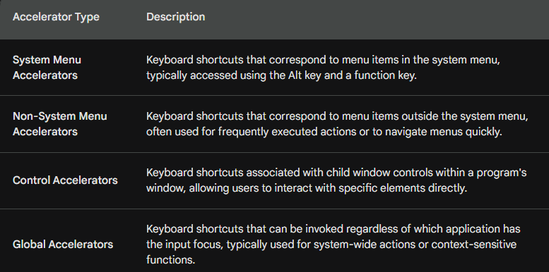

Additional Points:

* Accelerator IDs are unique identifiers assigned to each keyboard shortcut, allowing the window procedure to distinguish between different accelerators.
* Notification codes provide additional information about the type of command or action triggered by the accelerator.
* Child window handles identify the specific control associated with a control accelerator.
* Global accelerators are registered using the RegisterHotKey function and require elevated privileges in some cases.

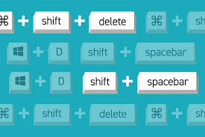

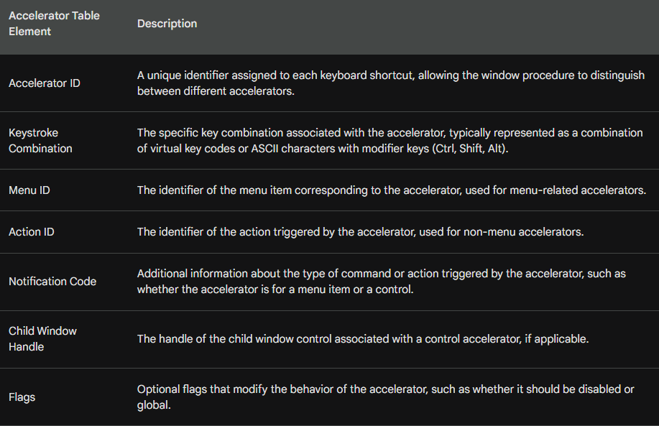

Basically, TranslateAccelerator handles your keyboard shortcuts. It turns your keypresses into commands the app understands, making it much faster to get things done.

*Popad2 program in chapter 10 folder….*

POPPAD2: A Rudimentary Notepad with Menus and Accelerators

POPPAD2 takes the foundation of our first version and makes it feel like a real application. Here’s what’s new:

* **Menus:** You now have File and Edit menus for quick access to "New," "Open," "Save," and more.
* **Shortcuts:** We’ve mapped menu items to keyboard shortcuts (accelerators) so you don't have to rely solely on the mouse.
* **Better Text Control:** Under the hood, we’re using an edit control to handle all the heavy lifting for editing, from "Select All" to "Undo."

FUNCTIONALITY BREAKDOWN

Menu & Resource Breakdown

**File Menu** For now, the File options (New, Open, Save, Print) are just placeholders; selecting them will simply trigger a beep. We’ll be implementing the actual logic for these in the coming chapters.

**Edit Menu** Most of these actions are handled by sending standard messages directly to the edit control:

* **Undo/Cut/Copy/Paste:** Sent via WM_UNDO, WM_CUT, WM_COPY, and WM_PASTE.
* **Clear:** Uses WM_CLEAR to wipe the selection.
* **Select All:** Uses EM_SETSEL to highlight everything at once.

The menu is also context-aware—options like "Cut" or "Copy" will automatically gray out if no text is selected.

**The Resource Files (.RC & RESOURCE.H)** To keep the code clean and readable, we use these two files to manage the app's "look and feel":

* **POPPAD2.RC:** This is our toolkit. It defines the icons, the layout of our File/Edit/Help menus, and the **Keyboard Accelerators** (like Ctrl+C for copy or F1 for help).
* **RESOURCE.H:** This maps numerical IDs to readable names (like IDM_EDIT_COPY). This way, we can refer to "Copy" in our code by name rather than a random number.

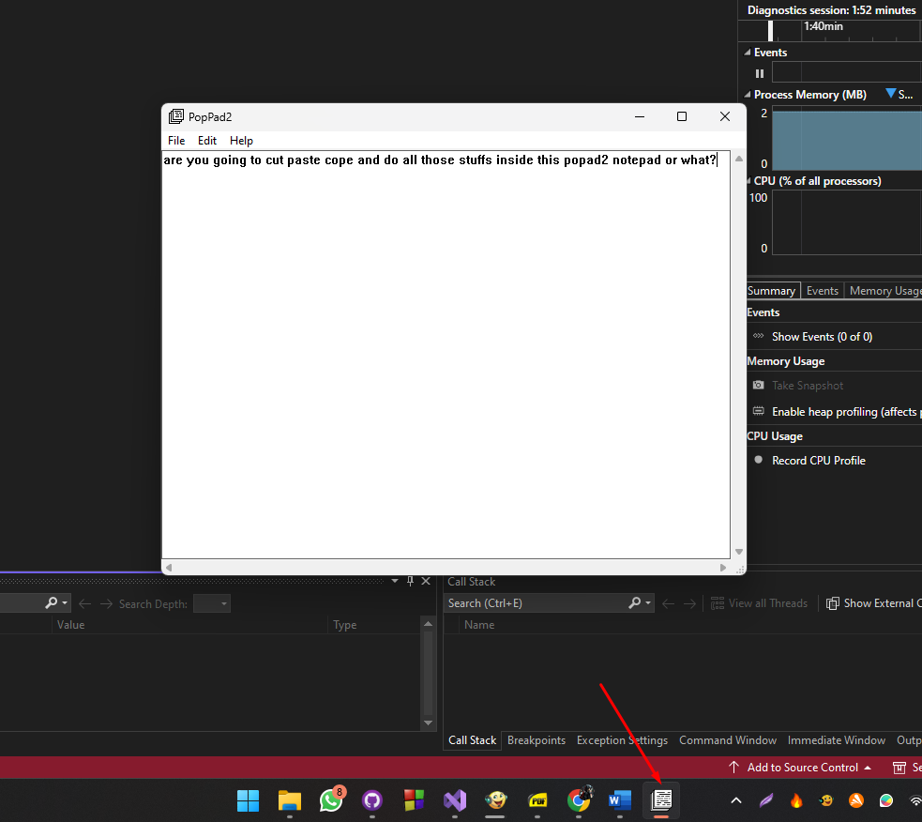

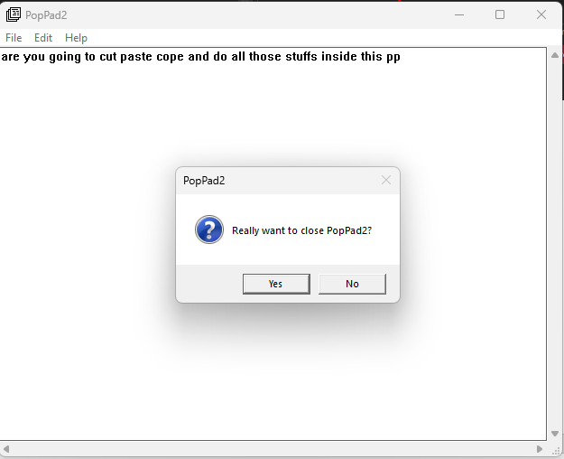 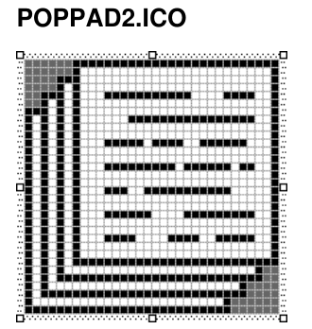

Deep Dive: Handling Menus and Accelerators

The POPPAD2.RC file isn't just a list; it’s where we tie the UI together. By using a tab (\t) in the menu strings, we display the shortcut keys right next to the command names, keeping the interface standard and clean.

I. Dynamic Menu Control (WM_INITMENUPOPUP)

Rather than keeping all menu items active at all times, POPPAD2 uses the WM_INITMENUPOPUP message to "audit" the menu before it even opens. This ensures the user only sees options that actually make sense in the moment:

* **Undo:** We query the edit control with EM_CANUNDO. If there’s nothing to undo, the option is grayed out.
* **Paste:** We check IsClipboardFormatAvailable. If there’s no text on the clipboard, "Paste" stays disabled.
* **Cut, Copy, & Delete:** We use EM_GETSEL to see if any text is highlighted. If the start and end positions are the same, it means nothing is selected, so these options are disabled.

II. Keyboard Accelerators

We’ve mapped standard Windows shortcuts (like Ctrl+Z, Ctrl+X, and Ctrl+V) to their respective IDs. This allows the application to catch these keystrokes and treat them exactly like a menu click, keeping our command logic centralized.

COMMAND PROCESSING: HOW IT WORKS

Because we are using a standard **edit control** (hwndEdit), handling the Edit menu is incredibly straightforward. Instead of writing complex text-manipulation logic, we simply forward the command to the control.

1. The Edit Menu

For most editing tasks, we just "pass the buck" to the edit control using SendMessage.

* **Undo, Cut, Copy, Paste, and Clear:** Each of these sends a single message—like WM_UNDO or WM_PASTE—directly to the edit control.
* **Select All:** Since there isn't a single "select all" message, we use SendMessage(hwndEdit, EM_SETSEL, 0, -1); to highlight everything from the first character to the last.

2. The Help Menu (About Box)

The "About" option simply triggers a standard Windows message box to display the app name and copyright info:



3. Graceful Exits & Confirmation

We want to make sure users don't lose their work by accident. To handle this, we split the exit logic into two steps:

**The Trigger:** When a user clicks "Exit" in the menu, we don't kill the app immediately. Instead, we send a WM_CLOSE message.

**The Confirmation:** Inside the WM_CLOSE handler, we call a custom function, AskConfirmation. This pops up a "Are you sure?" dialog.

* If the user clicks **Yes**, we call DestroyWindow().
* If they click **No**, we ignore the request and the app stays open.



4. Handling Shutdowns and Confirmations

To keep things consistent, we use a single helper function, AskConfirmation, whenever the app is about to close. This ensures the user always gets a "Are you sure?" prompt.

**The Confirmation Helper**

This simple function pops up a standard "Yes/No" dialog. It returns IDYES if the user confirms and IDNO if they change their mind.



5. Dealing with Windows Shutdown (WM_QUERYENDSESSION)

What happens if the user tries to shut down Windows while the app is open? Windows sends a WM_QUERYENDSESSION message to every open window to ask, "Is it okay to close you?"

* **If the user clicks "Yes"** in our prompt: We return 1 (True), telling Windows it’s safe to proceed with the shutdown.
* **If the user clicks "No"**: We return 0 (False). This actually stops the entire Windows shutdown process, giving the user a chance to save their work.

6. Final Notification (WM_ENDSESSION)

After the query, Windows sends WM_ENDSESSION. This is just a courtesy message that tells the app the final verdict: "Yes, we are definitely shutting down now" or "No, the shutdown was canceled."

MODAL VS. MODELESS: WHAT’S THE DIFFERENCE?

Think of a **Modal Dialog** like a "stop sign." When it pops up, you *must* deal with it (click OK or Cancel) before you can touch the main window again. This is what most "About" or "Settings" boxes are.

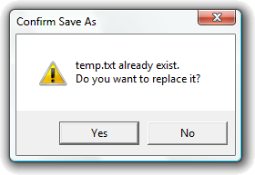

A **Modeless Dialog** is more like a "sticky note." It stays open, but you can still click back and forth between it and the main window (like the "Find and Replace" box in Word).

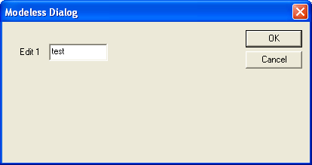

How the "ABOUT1" Program Works

To create a dialog box, the program uses three main parts:

1. The Resource File (.RC)

This is where you "draw" the dialog. Instead of writing code for every button, you define it in the resource file:

* **Styles:** DS_MODALFRAME tells Windows it’s a modal box; WS_POPUP gives it that classic pop-up look.
* **Controls:** You list the static text (labels), the icon, and the "OK" button.
* **Menu:** Defines the "Help" menu so the user has something to click to open the box.

2. The Main Code (WinMain & WndProc)

This part runs the main window. When you click "About" in the menu:

* WndProc catches the WM_COMMAND message.
* It calls the DialogBox() function.
* **Crucial Note:** Once DialogBox() is called, the main window "freezes" (goes modal) until the dialog is closed.

3. The Dialog Procedure (AboutDlgProc)

Just like your main window has a WndProc, your dialog has its own "brain."

* **WM_INITDIALOG:** This is where you set things up right before the box appears.
* **WM_COMMAND:** This waits for the user to click the "OK" button. When they do, the function calls EndDialog(), which kills the box and hands control back to the main window.

Designing The "About" Box Visually

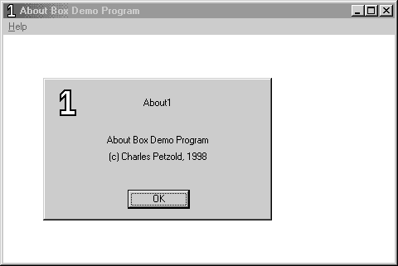

Instead of typing out coordinates in a text file, you can "draw" your dialog box using the Resource Editor. Here is the workflow for setting up the ABOUT1 box:

1. Creating the Canvas

* **Start the Dialog:** Go to the **Insert** menu → **Resource** → **Dialog**. You'll get a blank box with "OK" and "Cancel" buttons by default.
* **Set the Identity:** Right-click the box, hit **Properties**, and change the ID to AboutBox. This is the name your C/C++ code will use to find it.
* **Positioning:** Set the X and Y positions to 32. This ensures the box pops up in a consistent spot relative to your main window.

2. Refining the Style

* **Remove the Title Bar:** In the **Styles** tab, uncheck "Title Bar." This gives the box a cleaner, simpler look.
* **Clean up Buttons:** Since an "About" box only needs one way out, click the **Cancel** button and hit **Delete**. Move the **OK** button to the bottom-center.

3. Adding Content (Controls)

Use the **Controls Toolbar** to drag and drop elements onto your dialog:

* **The Icon:** 1. Pick the **Picture** tool and drag a square on the box. 2. In Properties, change the Type to **Icon** and set the ID to IDC_STATIC. 3. Select your icon name (About1) from the list.
* **The Text:** 1. Use the **Static Text** tool to place three labels. 2. In the **Caption** field, type your program name, version, and copyright info. 3. Set the alignment to **Center** in the Styles tab to keep it looking professional.

4. Fine-Tuning

* **Sizing:** You can drag the edges of the dialog to resize it.
* **Pixel-Perfect Accuracy:** Check the bottom-right corner of the screen; it shows the exact coordinates and size of whatever you are currently moving.
* *Tip:* Hold **Shift + Arrow Keys** to resize a control by a single pixel at a time.

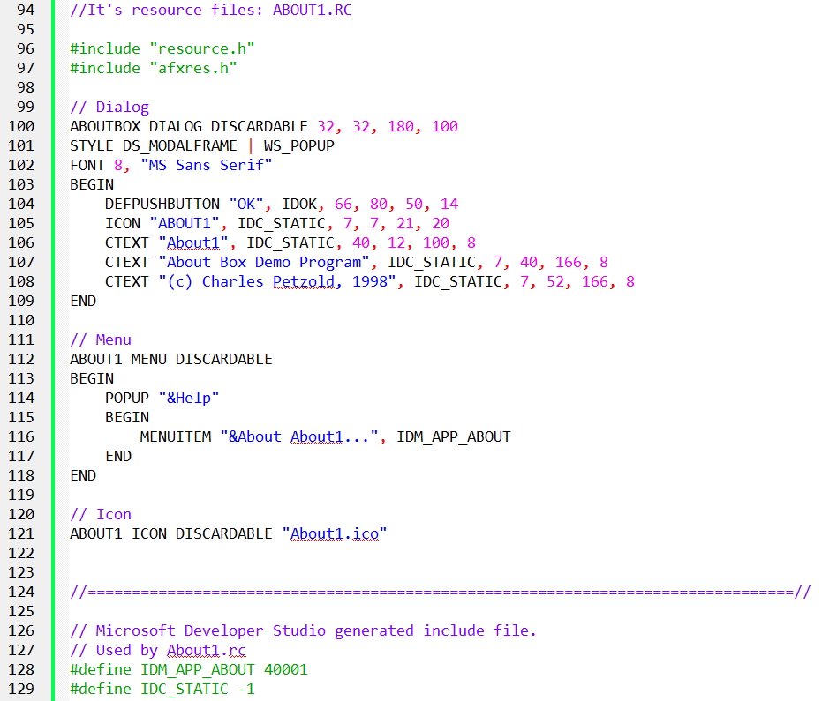

The Dialog Template: How Windows "Draws" the Box

When you see a line like ABOUTBOX DIALOG DISCARDABLE 32, 32, 180, 100 in the resource script, here is what actually matters:

1. "Dialog Units" vs. Pixels

The most important thing to remember is that **coordinates are not in pixels.** Windows uses "Dialog Units" based on the size of the system font.1

* **The Reason:** This ensures your dialog box doesn't look tiny on a high-resolution 4K monitor or huge on a low-res one. It scales automatically so the text always fits inside the buttons.
* **The Math (Optional):** X-units are $1/4$ of a character's width; Y-units are $1/8$ of a character's height.

2. The Style Flags

**WS_POPUP & DS_MODALFRAME:** These are the standard "ingredients" for a dialog.2 They tell Windows to remove the standard window borders and make it a solid, pop-up modal box.

3. Defining the "Innards" (BEGIN and END)

Everything between BEGIN and END is just a list of child controls. You only need to know three types for this program:

* **DEFPUSHBUTTON:** The "Default" button (usually OK).3 It’s the one that triggers if the user hits the Enter key.
* **ICON:** Just a placeholder that pulls the image from your resource file.
* **CTEXT:** "Centered Text." It’s a static label that automatically centers your text within the box you define.

The Building Blocks of the Dialog

In a resource script, you use "keywords" that are actually shortcuts for complex window settings.

1. The Three Main Controls

* **CTEXT (Centered Text):** This is just a "Static" window. It automatically combines the styles for being a child window, being visible, and centering the text.
* **ICON:** You don't need to set a size for this. Windows looks at your icon file and automatically makes the control the right size to fit the image.
* **DEFPUSHBUTTON:** This is the "Default" button. If the user hits **Enter**, Windows automatically "clicks" this button for them.

2. Understanding IDs

Every item in your dialog needs an ID so the program knows what is being clicked:

* **IDOK:** This is a built-in Windows ID (set to 1). It’s standard for the "OK" button.
* **IDC_STATIC:** This is set to **-1**. Because we never need to change the "About" text or the icon while the program is running, we give them this "dummy" ID. It tells Windows: "I'll never need to talk to this control again."

3. New Styles: Grouping and Tabbing

You'll see WS_GROUP and WS_TABSTOP in the code.

* **WS_TABSTOP:** Allows the user to move to this control using the **Tab** key.
* **WS_GROUP:** Helps group buttons together (like radio buttons).
* *Note: These aren't very important for a simple "About" box with only one button, but they become vital when you have complex forms.*

The Secret Language of Dialog Controls

In a normal window, you have to write long lines of code to create a button. In a **Dialog Template**, Windows gives you "shorthand" nicknames that do the heavy lifting for you.

1. The "Nickname" Identifiers

Instead of typing out CreateWindow with ten different parameters, you use these shortcuts:

* **CTEXT**: This is shorthand for a **Static Text** window that is already visible, centered, and attached as a child.
* **ICON**: You just give it a name, and Windows handles the rest. You don't even need to set a size; it just uses the dimensions of the icon file.
* **DEFPUSHBUTTON**: This is the "Main" button. It’s special because it reacts when the user hits the **Enter** key.

2. Understanding IDs (The Phone Numbers)

Every control needs an ID so the code knows who is talking.

* **IDOK (Value: 1)**: This is a built-in "VIP" ID. Windows already knows that this usually means "Close the box and save changes."
* **IDC_STATIC (Value: -1)**: This is the "Do Not Disturb" ID. Since we never need to change the "About" text while the app is running, we give it an ID of -1. This tells Windows, "I'm never going to send this control a message, so don't bother tracking it."

3. New Layout Rules

* **The Grid**: As we mentioned, everything is measured in **Dialog Units** (fractions of a character's size) so it looks right on any screen.
* **The "Group" Style**: You’ll see WS_GROUP and WS_TABSTOP. Think of these as "Navigation" markers. They tell Windows how to move the focus when the user presses the **Tab** key or the **Arrow** keys.

Understanding the ABOUT1 Dialog Box Procedure

This section delves into the code and functionality of the AboutDlgProc function, which handles messages for the ABOUT1 dialog box:

I. Function Definition:



Parameters:

* hDlg: Handle to the dialog box window.
* message: Message sent to the dialog box.
* wParam: Additional message-specific information.
* lParam: Additional message-specific information.

Return Type:

* BOOL: TRUE if the message is processed, FALSE otherwise.

Differences from a Window Procedure:

* Return Type: Dialog box procedures return BOOL (treated as int), while window procedures return LRESULT.
* Message Processing: Dialog box procedures return TRUE when handling a message and FALSE otherwise, unlike window procedures that require calling DefWindowProc if they don't handle the message.
* Messages Handled: Dialog box procedures don't handle WM_PAINT, WM_DESTROY, or receive WM_CREATE. They specifically handle WM_INITDIALOG for initialization and WM_COMMAND for user interactions.

The Dialog Procedure: How it Thinks

The AboutDlgProc is a callback function that handles messages specifically for the dialog. Here’s how it manages the conversation:

I. The Startup: WM_INITDIALOG

This is the very first message the dialog gets. It’s your chance to do any last-minute setup before the user sees the box.

* **The Focus Rule:** If you return TRUE, Windows automatically puts the "focus" (the blue highlight) on the first available button.
* **Manual Mode:** If you want the focus to start on a specific text box or a different button, you call SetFocus yourself and return FALSE.

II. The Interaction: WM_COMMAND

When the user interacts with the dialog—like clicking the "OK" button or hitting the Spacebar—Windows sends a WM_COMMAND.

* **Checking the ID:** The program looks at the message to see the ID. If it sees IDOK, it knows the user is done.
* **The Exit:** To close the box, you don't use DestroyWindow. Instead, you call EndDialog(hDlg, 1);. This kills the dialog and sends a "success" signal back to the main program.

III. Handling Everything Else

In a normal WndProc, you pass unhandled messages to DefWindowProc. **Don't do that here!**

* If you handled the message: Return TRUE.
* If you didn't handle it: Return FALSE. This tells Windows, "I'm not interested in this message; you handle it for me."

Why Keyboard Shortcuts Don't Work

You might notice your main app's shortcuts (like Ctrl+S) stop working while the "About" box is open.

**The Reason:** Modal dialog boxes have their own private "mini-message loop" inside Windows.

They don't check your main program's message queue, so they never "see" your keyboard accelerators. The dialog is strictly focused on its own buttons and controls.

How the "About" Box is Launched

Launching a dialog box is a bit like calling a specialized subcontractor to handle a specific task while the main boss (your main window) takes a break.

I. Getting the "Key" (The Instance Handle)

When your program first starts (WM_CREATE), it grabs its "Instance Handle" (hInstance). Think of this as the program's ID badge. You need this badge later to prove to Windows that you have the right to open the resources (like the dialog) stored in your file.

II. Waiting for the Click

Your main window keeps an eye out for a WM_COMMAND message. If it sees the ID IDM_APP_ABOUT, it knows the user just clicked "About" in the menu.

III. Calling the DialogBox Function

This is the moment of truth. The program calls the DialogBox function, which needs four things:

* **The ID Badge:** Your hInstance.
* **The Blueprint:** The name of the dialog in your resource file ("AboutBox").
* **The Parent:** Your main window handle (hwnd).
* **The Brain:** The name of the function that will handle the dialog's logic (AboutDlgProc).

IV. The "Pause" Button

One of the most important things to understand is that **DialogBox is a blocking call.** * When you call it, your main WndProc stops right there and waits.

* The "About" box takes over.
* The DialogBox function won't finish (or "return") until the user clicks OK and EndDialog is called.

V. How Users Close It

Users have three ways to trigger that "OK" button:

1. **Click it** with the mouse.
2. **Hit Spacebar** (if the button is highlighted).
3. **Hit Enter** (because we labeled it a "Default" button).

*Pro Tip:* Even though we didn't add a Cancel button, hitting **Escape** usually sends an IDCANCEL message automatically.

VI. Talking Back to the Parent

Even though the main window is "paused," it’s not dead. The dialog box is a "child" of the main window. If the dialog needs to tell the main window something, it can send a message "home" using: SendMessage(GetParent(hDlg), ...);

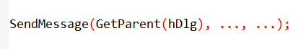

Customizing Your Dialog Boxes

While the visual editor is great, knowing how the resource script works allows you to tweak the "look and feel" of your windows in ways a drag-and-drop tool might miss.

I. Changing the Window Style

Our "About" box was very simple, but you can add standard window features by mixing and matching styles:

* **WS_CAPTION**: Adds a title bar at the top. This makes the window draggable so the user can move it out of the way.
* **WS_SYSMENU**: Adds that little icon in the top-left (or the 'X' in the top-right) so users can close or move the box using the system menu.
* **WS_THICKFRAME**: This makes the dialog box resizable. Usually, you don't want this for an "About" box, but it’s useful for complex tools.

II. Advanced Visual Tweaks

* **Custom Fonts**: You aren't stuck with the default system font. By using the FONT statement in your script, you can give your dialog a unique look (just make sure the user has that font installed!).
* **Adding Menus**: It’s rare, but you *can* actually put a menu bar (File, Edit, etc.) inside a dialog box just like a main window.
* **Custom Classes**: If you want your dialog to behave in a very specific, non-standard way, you can give it its own "Window Class." This is an advanced move we'll see later in the HEXCALC project.

III. Why Bother with Manual Scripting?

Even though Visual Studio has a visual editor, sometimes you need to "hand-code" the resource script.

* **Precision**: Sometimes it's faster to type a coordinate than to nudge a box with a mouse.
* **Complex Layouts**: For math-heavy apps like calculators, where every button needs to be perfectly aligned in a grid, writing the script manually (or using a loop to generate it) is much more efficient.

IV. Key Takeaway

A dialog box is just a window with special "pre-set" behaviors. By changing the styles in the resource script, you can make a dialog look exactly like a main application window or something entirely unique.

How Windows "Builds" Your Dialog

When you call DialogBox, you aren't just opening a window; you're handing Windows a "blueprint" (the template) and asking it to do the heavy lifting.

I. The Construction Process

Think of DialogBox as a high-level wrapper for CreateWindow. Here’s what Windows does once you call it:

* **Reads the Blueprint:** It pulls the coordinates, size, and style from your resource script.
* **Registers the Class:** Windows uses a special, built-in "Dialog Class" to make sure the window behaves like a dialog (handling things like the Tab key automatically).
* **Starts the Conversation:** It uses the address of your AboutDlgProc to send messages back and forth.

If you didn't use DialogBox, you would have to manually call CreateWindow for the main box and every single button or text label inside it—which is a massive headache!

II. Creating Dialogs "On the Fly" (DialogBoxIndirect)

Normally, you define your dialogs ahead of time in a resource file (.RC). But what if your program doesn't know what the dialog should look like until it's actually running?

* **DialogBoxIndirect** lets you build a dialog template in memory while the program is active.
* Instead of reading from a file, it reads from a data structure you created in your code. This is perfect for complex apps that need to generate custom menus or forms dynamically.

III. Shorthand for Child Controls

As we've seen, keywords like CTEXT or DEFPUSHBUTTON are just "shortcut" names. They tell Windows exactly which **Window Class** and **Style** to use without you having to type out long strings of code.

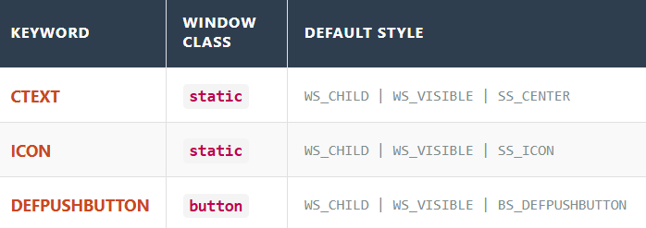

**NB:** The whole point of the Dialog system is **automation**. Windows takes your simple list of controls and handles the messy work of registering classes and creating multiple child windows so you can focus on the logic.

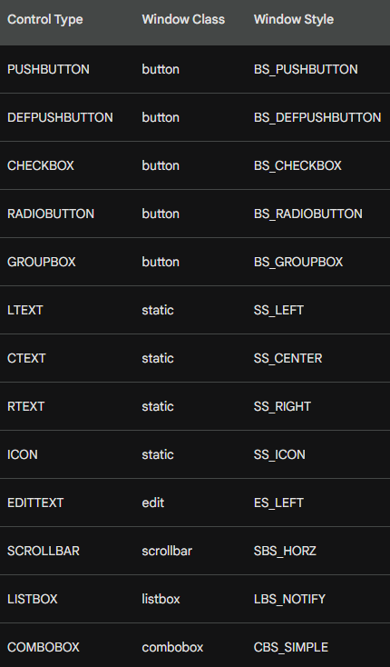

The Resource Compiler’s Cheat Sheet

Think of the Resource Compiler as a translator. It takes these shorthand lines and converts them into the complex CreateWindow calls that Windows actually understands.

**1. Two Main Formats** Most controls follow a simple "label first" pattern, but a few skip the text:

* **With Text:** control-type "Label", id, x, y, width, height, style *(Used for: Buttons, Icons, Static Text)*
* **Without Text:** control-type id, x, y, width, height, style *(Used for: Edit fields, Listboxes, Scrollbars, Comboboxes—where the user provides the content later)*

**2. Built-in Defaults** You don't have to tell Windows that a control is a child or that it should be seen. Every control in a dialog has these two "invisible" styles by default:

* WS_CHILD
* WS_VISIBLE

**3. The Optional Style Flag** The very last parameter (iStyle) is optional. You only add it if you want to give the control "extra powers," like making an edit box read-only or adding a border.

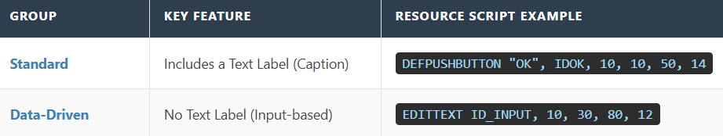

Fine-Tuning Your Controls

Think of the standard controls (like EDITTEXT) as "presets." Most of the time they work fine, but sometimes you need to go off-script.

I. The "Math" Reminder

Just a heads-up: Windows still uses those **Dialog Units** (1/4 character width, 1/8 character height) for every control you place. This keeps everything perfectly aligned, even if the user changes their screen resolution.

II. Using the "NOT" Trick

Usually, we add styles using the OR operator (|). But sometimes, you want to **remove** a feature that Windows includes by default.

**Example:** Most text boxes (EDITTEXT) come with a border. If you want a flat look, you use NOT WS_BORDER. This tells Windows: "Give me a text box, but take away the outline."

III. The "Power User" Statement: CONTROL

What if you want to use a control that doesn't have a shorthand nickname? Or what if you've invented your own custom UI element? You use the **CONTROL** statement.

It’s the most flexible way to build things because it doesn't make any assumptions. You have to tell it exactly what the "Class" is:

CONTROL "Submit", ID_SUB, "button", BS_PUSHBUTTON | WS_TABSTOP, 10, 10, 50, 14

How the "Dialog Manager" Works

When you launch a dialog, a background process called the **Dialog Manager** takes over. It acts like an automated construction foreman:

1. **The Shell:** It creates the empty popup window first.
2. **The Parts:** It loops through every CONTROL or CTEXT line in your script.
3. **The Build:** It calls CreateWindow for every single one of them, automatically converting your "Dialog Units" into real screen pixels.
4. **The Result:** You get a fully formed window with all its buttons and labels ready to go.

This next section shows you that there are two ways to write the exact same thing in your resource file. Think of it like a "Manual" way and a "Shortcut" way.

Two Ways to Build a Button

In your resource script, you can define an "OK" button using either of these lines. They result in the **exact same button** on your screen:

I. The "Manual" Way (CONTROL)

This is the detailed version. You have to list everything manually:

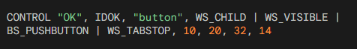

**Why use it?** It’s highly flexible. You can use it to create *any* type of window (like a custom graph or a special list) just by changing the class name ("button") or adding unique styles.

II. The "Shortcut" Way (PUSHBUTTON)

This is the simplified version. It’s much cleaner to read:



**Why use it?** It’s faster. When Windows sees PUSHBUTTON, it already knows you want the "button" class and the standard styles like WS_CHILD and WS_VISIBLE. You don't have to type them out every time.

Regardless of which way you write it, the parameters always follow this logic:

* **Label ("OK"):** What the user reads on the button.
* **ID (IDOK):** The "name" your C++ code uses to identify this button.
* **Location (10, 20):** The X and Y coordinates (starting from the top-left of the dialog).
* **Size (32, 14):** The width and height of the button.
* **Styles:** Extra rules, like WS_TABSTOP, which lets the user "land" on the button using the **Tab** key.

Think of the CONTROL statement as the "Pro Mode" for building dialog boxes. While shortcuts like PUSHBUTTON are great for standard stuff, CONTROL gives you total power over the details.

III. Why the CONTROL Statement is a Big Deal

Even though it’s more typing, the CONTROL statement is important for two main reasons:

1. It can create anything

With a shortcut like PUSHBUTTON, you are stuck making buttons. With CONTROL, you just change the "class" name to create whatever you want. You could put a scroll bar, a text entry box, or even a custom-made graph inside your dialog just by changing one word.

2. Total Style Control

Shortcuts give you the "standard" look. CONTROL lets you hand-pick every single behavior (style flag) the window has. If you want a button that behaves in a weird or specific way, this is how you build it.

IV. What’s Happening Behind the Scenes?

When you use the CONTROL statement, Windows does some of the work for you:

* **Automatic Settings:** You don't have to worry about telling Windows the control is a "child" or that it should be "visible." Even if you forget to type it, Windows automatically adds WS_CHILD and WS_VISIBLE for you.
* **The Translation:** When your program runs, Windows looks at that CONTROL line and translates it into a standard CreateWindow call. It calculates the exact pixel size based on the font you're using and places the control exactly where you asked.

What’s New in ABOUT2?

While ABOUT1 just showed a static box, **ABOUT2** is interactive. It lets the user pick colors and shapes that actually change the main window.

I. The Main Window (WndProc)

It does the usual stuff, but it adds a **WM_PAINT** handler. It uses two global variables—iColor and iFigure—to decide what to draw on the screen. When you change settings in the Dialog, this window redraws itself.

II. The Dialog Box (AboutDlgProc)

This is the "Control Panel." It has two main jobs:

* **Radio Buttons:** It uses CheckRadioButton to make sure only one option (like "Red") is picked at a time.
* **The "Preview" Window:** There is a small area inside the dialog box that shows you what your choice will look like before you hit OK.

III. Key Functions to Know

* **CheckRadioButton**: Automatically deselects the old choice when you click a new one.
* **GetDlgItem**: Helps the code find a specific button or text label inside the dialog by its ID.
* **InvalidateRect**: Tells a window (either the main one or the preview box) that it needs to redraw because the user changed a color or shape.

IV. The Resource Files (.RC and .H)

Think of these as the "Skin" and the "ID Cards":

* **ABOUT2.RC**: The blueprint. It uses GROUPBOX to draw boxes around the radio buttons and LTEXT as a placeholder for the preview area.
* **RESOURCE.H**: A list of IDs. IDC_ are for controls (buttons/circles) and IDM_ is for the menu.
* **ABOUT2.ICO**: The actual image file for the icon.



V. Summary of the Workflow

1. User clicks **Help → About**.
2. The Dialog pops up. User clicks a **Radio Button** for "Blue."
3. The Dialog's "Preview" area immediately turns blue.
4. User clicks **OK**. The Dialog closes and tells the main window to turn blue too.
5. If the user clicks **Cancel**, nothing changes.

Designing the ABOUT2 Dialog

When moving from a simple "About" box to one with choices (Radio Buttons), there are three things that matter in the Resource Editor:

I. The ID Sequence (The "Order" Rule)

When you create Radio Buttons (Black, Red, Green, etc.), create them **in order**.

* **Why?** It gives them sequential ID numbers (e.g., 101, 102, 103).
* **The Benefit:** This allows you to use a single line of code to handle the whole group instead of writing a separate "if" statement for every single button.

II. Using the "Group" Property

In the Resource Editor, you check the "Group" box for the **first** button in a set (like "Black" for colors and "Rectangle" for shapes).

* **How it works:** This tells Windows, "Start a new group here." All buttons following it will belong to that group until Windows hits another control with the "Group" property turned on.
* This ensures that clicking "Red" doesn't accidentally uncheck "Rectangle."

III. Tab Order

The order in which you click or create controls defines the **Tab Order**.

* This is simply the path the "focus" takes when a user presses the **Tab** key.
* *Pro Tip:* In the editor, you can usually press **Ctrl+D** to see the numbers and click them in the order you want the user to navigate.

IV. Summary for the Code

* **Sequential IDs** = Easier code logic.
* **"Group" Flag** = Keeps color choices separate from shape choices.
* **Tab Order** = Makes the dialog usable without a mouse.

How Buttons Talk to the Dialog Box

When you click a radio button, it doesn’t just change itself—it tells the Dialog Box what happened. This happens through a **notification message**.

I. The Message: WM_COMMAND

Think of WM_COMMAND as a status report sent to the Dialog Box every time a button is clicked. It contains:

* **Who:** The ID of the button (e.g., IDC_RED)
* **What:** The action code (usually BN_CLICKED)
* **Where:** The handle (the unique memory address of that button)

II. The Reaction: Handling the Click

Once the Dialog Box gets the message, it updates the UI. For example, if you click "Red," the code must:

* Put a dot in the Red button
* Remove the dots from Blue, Green, etc.

III. The Problem: How do I control buttons I didn’t click?

When you click "Red," the message only gives you the handle for Red. But your code also needs to **uncheck the other buttons**.

IV. The Solution: Two Easy Functions

**Step A: Find the button** (GetDlgItem)  
Since you only know the button’s ID (e.g., IDC_BLUE), ask Windows for its handle:

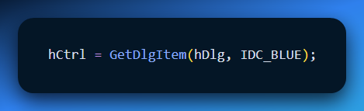

**Step B: Send an order** (SendMessage)  
Now that you have the handle, tell it to check or uncheck using BM_SETCHECK:

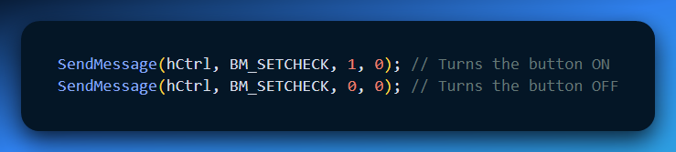

* 1 = Check it
* 0 = Uncheck it

V. The "Manual" Loop: How it works

If you were to write the logic yourself (the long way), you would use a loop to "talk" to every button in the group. The Logic:

1. **Catch the Click:** When you click a color, LOWORD(wParam) tells the program which ID was picked.
2. **The Loop:** The program cycles through every ID from IDC_BLACK to IDC_WHITE.
3. **The Decision:** If the ID in the loop **matches** the one you clicked, the program sends a 1 (Check it). If it **doesn't match**, it sends a 0 (Uncheck it).

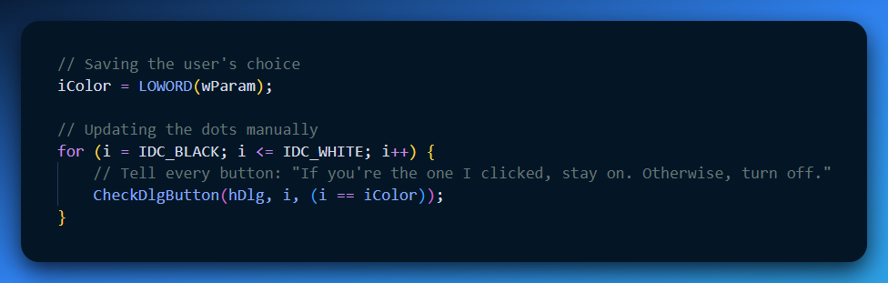

The Ultimate Shortcut: CheckRadioButton 💡

In a real Windows program, nobody writes that loop! Windows provides a built-in "Easy Button" called CheckRadioButton. It does the searching, the handles, and the checking for you in **one line**.

**The Shortcut Command:** CheckRadioButton(hDlg, IDC_BLACK, IDC_WHITE, iColor);

What this one line does:

* **hDlg**: Looks at your dialog box.
* **IDC_BLACK**: Starts at the first button in the group.
* **IDC_WHITE**: Stops at the last button in the group.
* **iColor**: Puts the dot in the one you actually clicked and automatically clears all the others.

**Why this matters**

* **Sequential IDs:** This is why we created the IDs in order (Black, Red, Green...). The function just counts from the "Start ID" to the "End ID."
* **Clean Code:** You replace a 10-line loop with a single, readable command.

Dialog Box Shortcuts for Radio Buttons and Check Boxes

This section discusses shortcuts available in Windows for handling radio buttons and check boxes in dialog boxes.

1. SendDlgItemMessage:

This function provides a shortcut to send messages directly to child controls within a dialog box. It takes five arguments:

* hDlg: The window handle of the dialog box.
* id: The ID of the child control.
* iMsg: The message identifier to send.
* wParam: Additional message-specific parameter.
* lParam: Additional message-specific parameter.

This function is equivalent to:



2. CheckRadioButton:

This function simplifies checking and unchecking radio buttons within a specific range. It takes four arguments:

* hDlg: The window handle of the dialog box.
* idFirst: The ID of the first radio button in the range.
* idLast: The ID of the last radio button in the range.
* idCheck: The ID of the radio button to check.

This function unchecks all radio buttons in the specified range except for the one with the idCheck value, which will be checked.

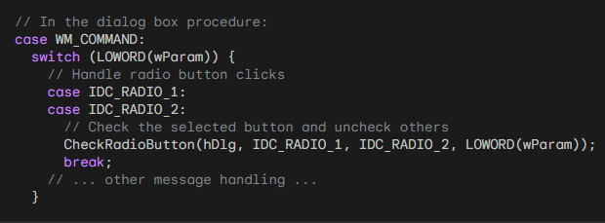

3. CheckDlgButton:

This function controls the check mark of a check box within a dialog box. It takes three arguments:

* hDlg: The window handle of the dialog box.
* idCheckbox: The ID of the check box.
* iCheck: Whether to check (1) or uncheck (0) the box.

Setting iCheck to 1 checks the box, while setting it to 0 unchecks it.

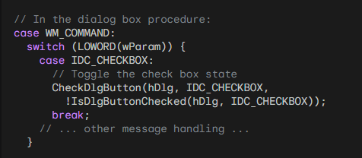

4. IsDlgButtonChecked:

This function retrieves the current check state of a check box within a dialog box. It takes two arguments:

* hDlg: The window handle of the dialog box.
* idCheckbox: The ID of the check box.

The function returns 1 if the checkbox is checked, and 0 if it is unchecked.

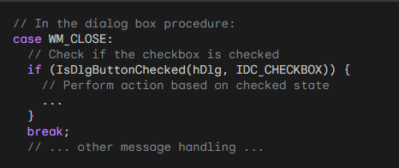

Using CheckDlgButton with BS_AUTOCHECKBOX:

If you define a checkbox with the BS_AUTOCHECKBOX style, you don't need to process the WM_COMMAND message. You can simply use IsDlgButtonChecked to retrieve the current state of the checkbox before closing the dialog box.

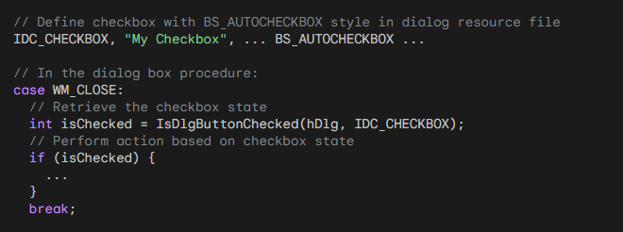

Using BS_AUTORADIOBUTTON:

With the BS_AUTORADIOBUTTON style, using IsDlgButtonChecked is inefficient because you would need to call it for each button until it returns true. Instead, you should still trap WM_COMMAND messages to track the selected button.

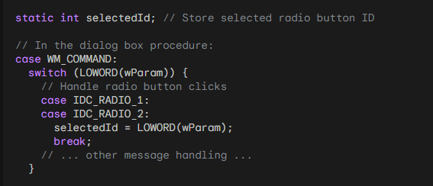

Remember to replace IDC_ constants with your actual control IDs.

These shortcuts offer several benefits:

* Improved code readability and conciseness.
* Reduced code complexity compared to using SendMessage and loops.
* Increased efficiency, especially for CheckRadioButton.

By using these shortcuts, you can improve the overall quality and maintainability of your code when dealing with radio buttons and check boxes in dialog boxes.

Handling OK and Cancel Buttons in a Dialog Box

This section dives deep into the behavior of OK and Cancel buttons in ABOUT2's dialog box, focusing on keyboard interaction and message handling.

Button IDs and Default Button:

* The OK button has an ID of IDOK (defined as 1).
* The Cancel button has an ID of IDCANCEL (defined as 2).
* The OK button is the default button, denoted by DEFPUSHBUTTON in the dialog resource file.

Keyboard Interaction:

* Pressing Enter sends a WM_COMMAND message with the LOWORD of wParam set to the ID of the default button (IDOK) unless another button has focus (then that button's ID is used).
* Pressing Esc or Ctrl+Break sends a WM_COMMAND message with the LOWORD of wParam set to IDCANCEL.

Message Handling in AboutDlgProc:

The switch statement checks the LOWORD of wParam:

For IDOK:

* Saves the selected color and figure to global variables.
* Calls EndDialog(hDlg, TRUE).
* Returns TRUE.

For IDCANCEL:

* Calls EndDialog(hDlg, FALSE).
* Returns TRUE.

EndDialog and its Significance:

* EndDialog closes the dialog box and returns control to the main window procedure.
* The second parameter of EndDialog is passed back as the return value of DialogBox.
* In ABOUT2, TRUE signifies OK and FALSE signifies Cancel.
* This value helps the main window determine the user's action and update accordingly.

Benefits of TRUE and FALSE:

Using TRUE and FALSE simplifies communication between the dialog box and main window.

It provides a clear and concise way to indicate user intent.

Beyond TRUE and FALSE:

The argument to EndDialog is an int, allowing for more nuanced information.

This could be useful for passing multiple values or specific user choices.

Code Example:

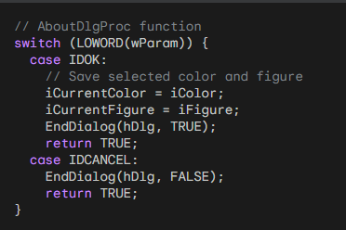

Additional Notes:

* Windows handles the translation of keyboard shortcuts like Enter, Esc, and Ctrl+Break.
* This simplifies the dialog box procedure by eliminating the need for specific keyboard handling code.
* Understanding how OK and Cancel buttons work with keyboard interaction and message handling is crucial for creating user-friendly dialog boxes.

Using Structures to Avoid Global Variables in Dialog Boxes

While global variables can be convenient, excessive use can lead to code that's difficult to maintain.

In the case of ABOUT2, where the iCurrentColor and iCurrentFigure variables are used in both the window procedure and the dialog procedure, using a structure can offer a more robust and organized approach.

Structure Definition:

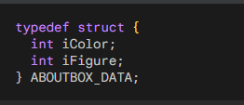

Window Procedure (WndProc):

Define and initialize a static variable based on the structure:



Replace all occurrences of iCurrentColor and iCurrentFigure with ad.iColor and ad.iFigure respectively.

Use DialogBoxParam with the structure as the last argument:

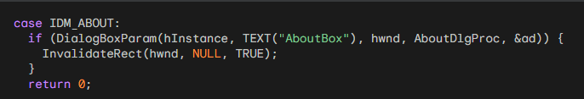

Dialog Procedure (AboutDlgProc):

Define two static variables:



In the WM_INITDIALOG message handler:

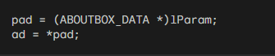

Throughout the dialog procedure, replace iColor and iFigure with ad.iColor and ad.iFigure respectively.

When the user presses OK:

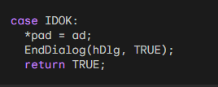

Benefits:

* Reduced Global Variables: Eliminates the need for separate global variables for the dialog box data.
* Improved Organization: Encapsulates all dialog box-related data within a single structure.
* Enhanced Code Clarity: Makes code easier to understand and maintain by explicitly defining the data structure.
* Increased Flexibility: Allows for easily adding more data to the structure if needed.

Additional Notes:

* This approach can be applied to any dialog box in your program, promoting consistency and organization.
* By using structures and passing them via DialogBoxParam, you can avoid cluttering your code with global variables, leading to a cleaner and more maintainable codebase.

TAB STOPS AND GROUPS IN DIALOG BOXES

This section details how tab stops and groups work in dialog boxes, along with their implementation using window styles and keyboard interaction.

Tab Stops:

* Controls with the WS_TABSTOP window style receive focus when the Tab key is pressed.
* By default, some controls like radio buttons and push buttons include WS_TABSTOP.
* Other controls, like static text, do not have it by default as they don't require input focus.
* Unless explicitly set, the first control with WS_TABSTOP receives focus upon opening the dialog box.

Groups:

* Controls with the WS_GROUP window style mark the beginning of a group for cursor key navigation.
* Cursor keys move focus within a group, cycling back to the first control if necessary.
* Controls like LTEXT, CTEXT, RTEXT, and ICON have WS_GROUP by default, marking group ends.
* Other controls might need explicit addition of WS_GROUP to define group boundaries.

Example: ABOUT2 Dialog Box:

* The first radio button in each group and both push buttons have WS_TABSTOP.
* The first radio button in each group and the default push button have WS_GROUP.
* This allows Tab key navigation between groups and cursor key navigation within groups.
* Pressing the underlined letter in a group label focuses the currently checked radio button.

Windows Magic:

* Windows automatically updates the WS_TABSTOP style for the currently checked radio button.
* This ensures the Tab key always focuses the chosen option within a group.

Additional Functions:

* GetNextDlgTabItem: Retrieves the next or previous tab stop control based on bPrevious parameter.
* GetNextDlgGroupItem: Retrieves the next or previous group item based on bPrevious parameter.

Benefits:

* Simplifies keyboard interaction within dialog boxes.
* Provides intuitive navigation for users.
* Enhances accessibility for users with limited mouse input.

Code Example:

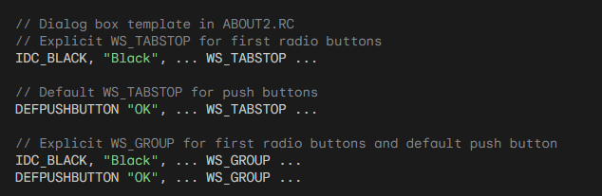

Tabstop is a feature in some dialog boxes that allows you to move between controls using keyboard shortcuts:

* Tab key: Pressing the Tab key moves focus from one control with the WS_TABSTOP style to the next in the tab order.
* Cursor keys: Within a group of controls marked with the WS_GROUP style, the cursor keys (up, down, left, right) move focus between the controls in that group.
* Underlined letters: Pressing the underlined letter in a group label focuses the currently checked radio button within that group.

This feature makes navigating dialog boxes easier and more efficient, especially for users who may have difficulty using a mouse.

Here are some additional details about tabstops:

* The first control with the WS_TABSTOP style receives focus when the dialog box opens, unless otherwise specified.
* Some controls, like radio buttons and push buttons, have the WS_TABSTOP style by default. Others, like static text, lack it by default and require explicit addition.
* Controls like LTEXT, CTEXT, RTEXT, and ICON have the WS_GROUP style by default, marking group boundaries. Other controls might need explicit addition of WS_GROUP to define group boundaries.
* Windows automatically adds the WS_TABSTOP style to the currently checked radio button within a group. This ensures that the Tab key always focuses the chosen option within a group, enhancing user experience.
* Two functions are available in Windows: GetNextDlgTabItem and GetNextDlgGroupItem. These functions retrieve the next or previous tab stop control or group item based on a parameter.

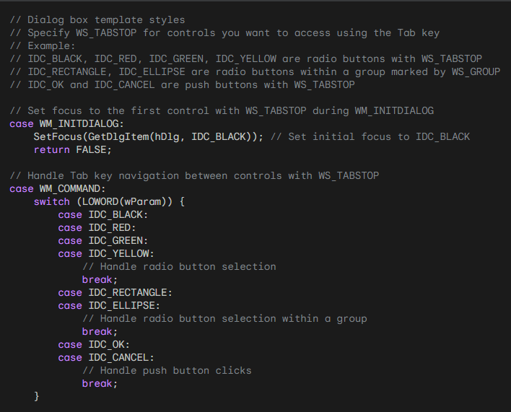

Overall, tabstop is a valuable feature that improves the usability and accessibility of dialog boxes.

PAINTING ON THE ABOUT2 DIALOG BOX

The ABOUT2 dialog box showcases a unique feature: custom painting within its own client area. This section delves deeper into the mechanics behind this achievement, analyzing the code and explaining the key concepts involved.

The Blank Canvas: An LTEXT Control Takes Center Stage

The foundation of this custom painting lies in ABOUT2.RC, where a static LTEXT control is defined with specific positioning and size. This control, despite having no text assigned, serves as the canvas upon which the desired artwork is drawn. Its dimensions, 18 characters wide and 9 characters high, determine the boundaries of the painting area.

Initiating the Painting Process: From User Interaction to Function Calls

When the user interacts with the dialog box, selecting a different color or figure option, a specific chain of events unfolds. This chain ultimately leads to the execution of the PaintTheBlock function, responsible for orchestrating the painting process.

Step-by-Step Breakdown of PaintTheBlock:

Invalidation: The function begins by invalidating the child window control using InvalidateRect. This triggers the control to send a WM_PAINT message, requesting its own redrawing.

Message Generation: UpdateWindow is called, ensuring that the WM_PAINT message is sent to the child window control, effectively notifying it of the need to repaint its client area.

Painting Orchestration: Finally, PaintWindow, another function within ABOUT2.C, is invoked. This function takes the reins and handles the actual drawing process.

The Inner Workings of PaintWindow: Bringing the Figure to Life

PaintWindow performs several crucial tasks to achieve the desired painting effect:

Device Context Acquisition: It first retrieves a device context handle for the child window control. This context acts as the bridge between the painting code and the actual drawing surface.

Figure Drawing: Based on the provided color and figure parameters, the function draws the selected figure onto the canvas. The choice of color dictates the brush used for filling the figure, creating the visual representation.

Pixel-Perfect Positioning: To ensure accurate drawing, PaintWindow utilizes GetClientRect to retrieve the child window's dimensions in pixels. This ensures that the figure is drawn within the designated bounds of the painting area.

Coloring the Canvas: The chosen color is brought to life by creating a brush based on its value. This brush is then used to fill the drawn figure, breathing life into the artwork.

Beyond the Technicalities: Benefits and Considerations

This approach to custom painting offers several advantages:

Targeted Painting: It enables painting on a specific area within the dialog box, leaving the remaining client area untouched.

Leveraging Standard Mechanisms: By utilizing the existing WM_PAINT message handling for child controls, the code adheres to established Windows procedures, promoting efficiency and maintainability.

Organizational Clarity: Separating the painting logic into a dedicated function (PaintWindow) enhances code organization and simplifies the main dialog procedure.

Alternative Approaches:

While GetClientRect effectively retrieves pixel dimensions, another option exists:

* MapDialogRect. This function offers a different approach, converting character coordinates defined in the dialog box template to pixel coordinates within the client area.

Conclusion: Unveiling the Art of Dialog Box Painting

The ABOUT2 dialog box demonstrates a clever and effective technique for achieving custom painting within a dialog box environment. By leveraging a child window control and its WM_PAINT message handling, the code draws the desired figure within the designated area, offering a glimpse into the creative possibilities within Windows applications. This approach serves as a valuable example for developers seeking to enhance the visual appeal and functionality of their dialog boxes.

EXPLORING ADVANCED TECHNIQUES FOR DIALOG BOXES:

This section delves into additional functions and capabilities associated with dialog boxes, venturing beyond the basics.

Beyond Basic Functionality: Moving Controls and Enabling/Disabling Features

While dialog boxes offer a pre-defined set of functionalities, some occasions call for further customization. Fortunately, developers can leverage existing Windows functions to achieve desired effects:

* MoveWindow: This function, originally meant for child windows, can be employed in dialog boxes as well. It allows developers to dynamically move controls around the dialog box, creating a unique or playful experience for users.
* EnableWindow: This function offers control over the interaction capabilities of individual controls within a dialog box. By setting the 'bEnable' parameter to TRUE or FALSE, developers can enable or disable specific controls based on user interactions or other conditions. This ensures that only relevant options are available at any given time, enhancing the user experience.

Dynamic Dialog Boxes: Enabling On-the-Fly Control

Dialog boxes often require adjustments based on user choices or other dynamic factors. Here's how developers can achieve this level of flexibility:

* EnableWindow: As mentioned earlier, this function plays a crucial role in adapting the dialog box to user actions. By dynamically enabling and disabling controls based on selections or other inputs, developers can create a more responsive and intuitive experience.
* Custom Control Definition: While Windows provides various standard controls, developers can define their own to fulfill specific needs. For instance, instead of using rectangular push buttons, a developer could create elliptical ones by registering a custom window class and implementing a dedicated window procedure. This level of customization allows for unique and innovative dialog box designs.

A Case Study: ABOUT3 and Custom Elliptical Buttons

The ABOUT3 program serves as a concrete example of defining custom controls within a dialog box. This program utilizes a custom window class and window procedure to create elliptical push buttons, replacing the standard rectangular buttons. This demonstrates how developers can extend the capabilities of dialog boxes beyond their default functionality.

By venturing beyond basic functionalities and exploring advanced techniques like custom control definition and dynamic manipulation of controls, developers can unlock the full potential of dialog boxes.

These advanced techniques can enhance the user experience, create unique and visually appealing interfaces, and adapt the dialog box behavior to specific needs, ultimately leading to more engaging and interactive applications.

About 3 program in Chapter 11 folder….



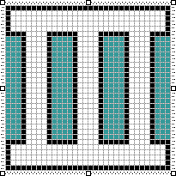 The icon for the program.

About3 demonstrates several unique aspects compared to standard dialog boxes:

1. Custom Elliptical Push Buttons:

Instead of utilizing the standard rectangular push buttons, About3 defines its own "EllipPush" control. This custom control uses a dedicated window class and its associated window procedure (EllipPushWndProc) to handle messages and draw elliptical buttons. This showcases the ability to create custom controls beyond the standard offerings.

2. Painting on the Dialog Box:

While other dialog boxes typically handle painting within their child controls, About3 takes a different approach. It leverages the WM_PAINT message and a dedicated function (PaintWindow) to directly paint on the client area of the dialog box itself. This allows for drawing outside the boundaries of child controls, offering greater flexibility.

3. Dynamic Control Behavior:

About3 utilizes the EnableWindow function to dynamically enable and disable the "OK" button based on user actions. This allows for a more responsive and interactive experience, ensuring only relevant options are available at any given time.

4. Interfacing with Parent Window:

The EllipPushWndProc function demonstrates how custom controls can communicate with their parent window. When the user interacts with the elliptical button, a message is sent to the parent dialog box, notifying it of the user's action. This enables custom controls to trigger specific behaviors within the containing dialog box.

5. Text and Color Customization:

About3 showcases how custom controls can manipulate their own text and color attributes. The EllipPushWndProc function retrieves the button's text and paints it on the elliptical surface. Additionally, it uses system colors to fill the ellipse and render text, ensuring visual consistency with the overall theme.

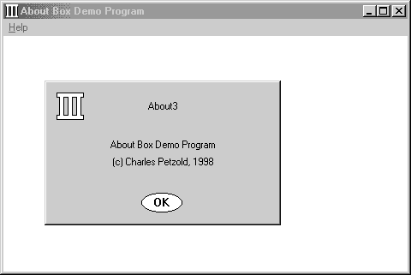

Key Takeaways from About3's Custom Control:

1. EllipPush Window Class:

This section dives deeper into the unique aspects of the EllipPush custom control:

* Window Class Registration: Unlike standard controls, EllipPush requires registering its own window class with specific attributes. This class defines the behavior and appearance of the elliptical buttons.
* Dialog Box Integration: Within the dialog editor, the "Custom Control" option allows embedding an EllipPush instance. Setting the "Class" property to "EllipPush" replaces the standard DEFPUSHBUTTON statement in the dialog box template. This binds the button to the custom window class.

2. EllipPushWndProc Function:

This function serves as the heart of the EllipPush control:

* Message Processing: It handles three specific messages: WM_PAINT, WM_KEYUP, and WM_LBUTTONUP.
* WM_PAINT Handling: This message triggers the drawing of the ellipse and its text. GetClientRect retrieves the button's size, while GetWindowText obtains the displayed text. The Windows API functions Ellipse and DrawText are then utilized to draw the desired shape and text within the button's boundaries.
* User Interaction: Both WM_KEYUP (with SPACE key) and WM_LBUTTONUP (mouse click) events trigger the same behavior. The control sends a WM_COMMAND message to its parent window (dialog box) with its ID as wParam. This informs the dialog box of the user's action and allows it to respond accordingly.

3. Benefits and Applications:

Creating custom controls like EllipPush offers several benefits:

* Visual Customization: It enables developers to design buttons and other controls with unique shapes and appearances, exceeding the limitations of standard controls.
* Enhanced Interaction: Custom controls can handle user interaction in specific ways, providing more tailored and engaging experiences.
* Extending Functionality: By defining custom window procedures, developers can implement functionalities not readily available in pre-built controls.

4. Broader Implications:

The EllipPush example serves as a stepping stone for exploring further customization possibilities within dialog boxes. Developers can leverage this approach to create various custom controls, each with its own unique design, interaction patterns, and functionalities. This opens doors to richer and more interactive dialog box experiences.

ELLIPPUSHWNDPROC: BEYOND THE BASICS

While EllipPushWndProc demonstrates the core functionality of a custom child window control, it lacks certain features and optimizations found in standard controls. Here's a deeper look at what's missing:

Button Flashing: Unlike standard push buttons, the EllipPush button doesn't visually indicate activation by flashing its colors. To achieve this effect, the window procedure needs to handle WM_KEYDOWN (Spacebar) and WM_LBUTTONDOWN messages. By inverting the interior colors on these events and restoring them on release or loss of focus, the button simulates the visual feedback of standard buttons.

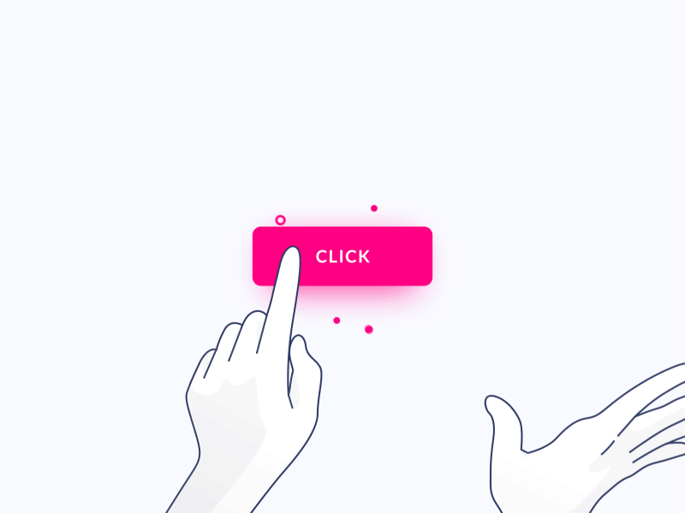

Mouse Capture: To handle clicks outside the button's bounds while it's pressed, the window procedure should capture the mouse on WM_LBUTTONDOWN. This involves setting the capture flag with SetCapture. If the mouse moves outside the button's area while the button is depressed, the window procedure should track the mouse movement and release the capture (and restore normal colors) on WM_MOUSEMOVE. Only if the button is released within its bounds should a WM_COMMAND message be sent to the parent.

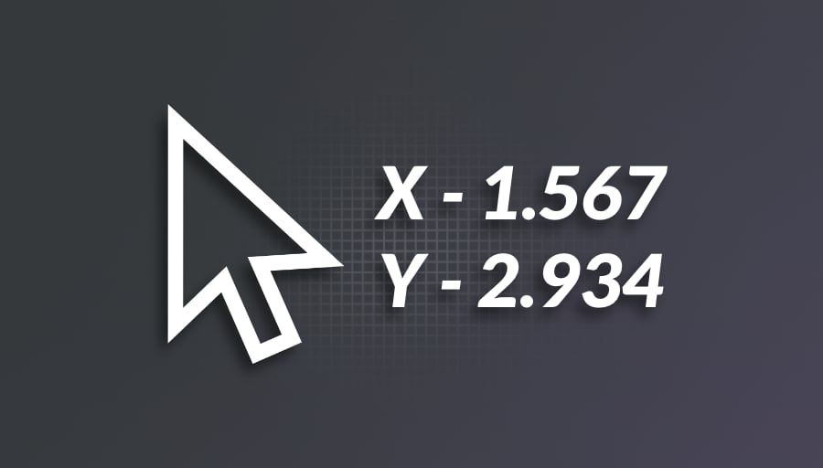

Handling WM_ENABLE: Currently, EllipPushWndProc doesn't respond to WM_ENABLE messages. When a dialog box disables a control using EnableWindow, the control's text should turn gray to indicate its inactive state. To achieve this, the window procedure needs to process WM_ENABLE and update the text color based on the message's wParam value.

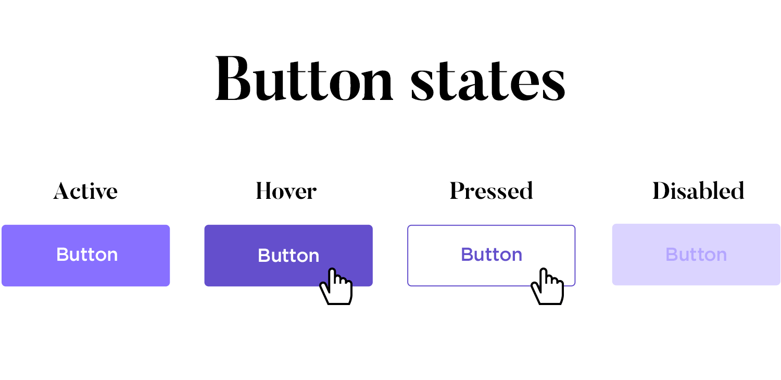

Control-Specific Data Storage: If a child window requires storing data specific to each instance, it can leverage the cbWndExtra field in the window class structure. By setting this value to a positive value, the control allocates additional memory within its internal structure. This memory can be accessed and manipulated using SetWindowLong and GetWindowLong, allowing for custom data storage and retrieval.

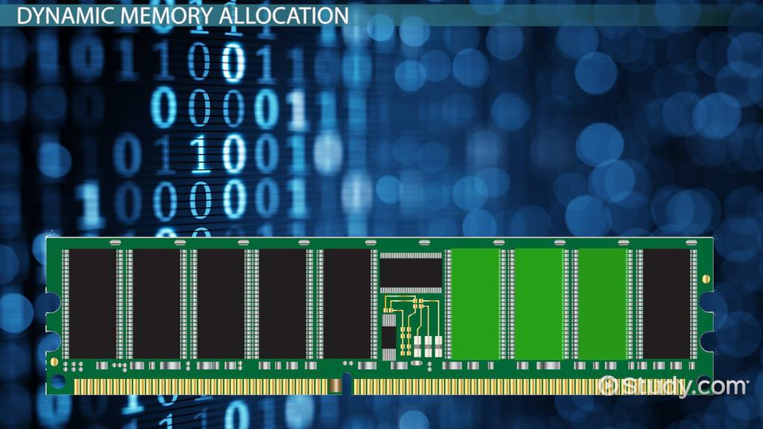

By addressing these aspects, EllipPushWndProc can be enhanced to provide a more complete and user-friendly custom control experience, offering functionality comparable to standard controls while maintaining the flexibility and customization possibilities of custom control creation.